**Group No.: 50**

PROJECT TOPIC: Resume Analyzer

**Project Group Members:**

**1.**Saksham Gangwar (B-51/201500603) **2.**Shreyash Varshney (F-59/201500675)

**3.**Sanjeev Kumar (B-54/201500617) **4.**Kaustubh Dubey (B-30/201500332)

**Project Supervisor:** Dr. Mayank Srivastava (Associate Professor)

* **About the Project:** In the world of recruitment and hiring - our Resume Analyzer. In an era where talent acquisition is more critical than ever, this tool is designed to empower both employers and job seekers by streamlining the resume evaluation process.
* As we all know, the traditional method of manually reviewing hundreds or even thousands of resumes can be a time-consuming and often daunting task for HR professionals. Job applicants, on the other hand, face the challenge of ensuring their resumes stand out in a highly competitive job market.

**Motivation:** Our Resume Analyzer addresses these challenges head-on by leveraging cutting-edge technology, including Natural Language Processing and Machine Learning, to transform the way resumes are assessed and matched to job openings.

**Project Planning:**

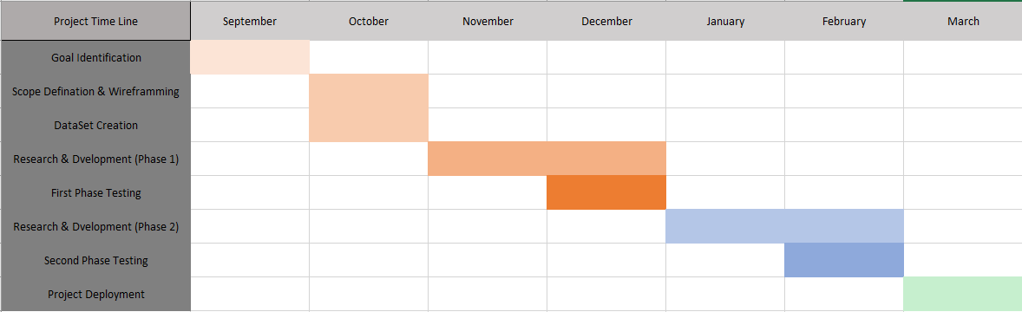

**Tools required:**

* + **Hardware Requirements:**

1. **Laptop 8gb RAM**
2. **Proper Internet Connection**
   * **Software Requirements:**
   1. **Python**
   2. **JupiterNoteBook**
   3. **Visual Studio Code**
   4. **PyCharm**
   5. **Windows 10**

**Signature of Project Supervisor:**